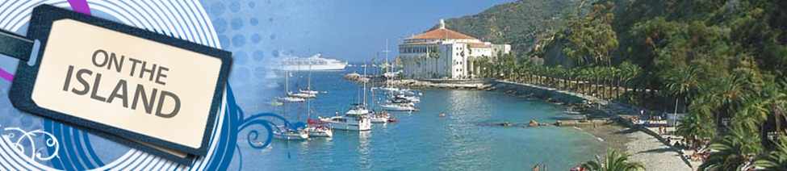
Santa Catalina Day Outing – Saturday, September 15, 2012 – FULLY BOOKED
UPDATE: NEW DATE: SATURDAY, SEPTEMBER 22, 2012 (CONFIRMATION REQUIRED)
Come One, Come All! Join Us for a Fun Day at the Santa Catalina Island.

- Price for seniors (55+ years) = $34.00 each way or $68.00 round trip. No group discount.
- Price for adults (12 – 54 years) = $37.25 each way or $74.50 round trip. Group discount for 20 people is available.
- Ride free on your birthday
- Departure from Dana Point to Avalon 7:45 am ** 11:55 am 5:00 pm
- Departure from Avalon to Dana Point 9:45 am 2:00 pm 7:00 pm **
- Address of the departure: 34675 Golden Lantern St, Dana Point, CA
- Dana Point/Avalon trips are approximately 1 hour & 30 minutes
- Advance reservations are recommended to ensure there are tickets available and we leave and arrive as a group. Please confirm your interest and commitment by Sept. 9th.
- Parking is $12.00 per day.
- Information (800) 481-3470. Call Center Agents are available from 5:45 a.m. - 8 p.m.
- http://www.catalinaexpress.com/index.php or http://www.catalinachamber.com/catalina/

ACTIVITIES
Relaxation on the beach:
Avalon’s beachfront is lined with South Beach, Middle Beach and Step Beach—all are conveniently located in the center of town and within easy walking distance of hotels, restaurants, shopping, and land activities.
Avalon Scenic Tour: The Perfect Introduction to the Town Of Avalon
11:00 am; 12:00pm; 1:00pm; 2:15pm; 3:15pm
Adults - $12.00; Children/Seniors - $10.00
Rediscover the enchantment of Avalon on this delightful journey along the beachfront, up the hillsides, and through the heart of this friendly and historic town. You’ll see picture-perfect views and colorful local attractions as your guide shares interesting Catalina Island history and folklore from the comfort of our passenger vehicle. This seven-and-a-half mile journey provides a comprehensive history of Santa Catalina Island’s most dynamic location.
17th Annual Catalina Island Women's Forum Wine Festival
9/15/12. From 2-5 pm. Tickets - $75.00.
Features over 70 wineries, delectable hors d'oeuvres, silent auction and live music. Net proceeds help support Catalina Island Women's Forum mentoring and scholarship programs. The festival will be located adjacent to the world famous Casino Building, overlooking beautiful Descanso Bay.

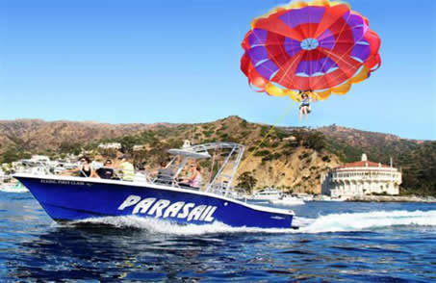
Parasailing
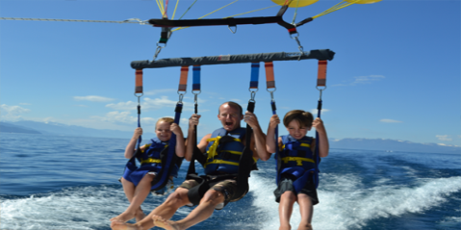
Take sightseeing to new heights over Avalon Bay! Fly solo or share the thrill with another on a doubles flight. Pricing:
Standard 600 ft. Flight: $65 per person
Premium 800 ft. Flight: $79 per person
Ride Along (not flying): $20 per person
Photo Package: $20

Glass Bottom Boat Voyage
Duration: 40 Minutes
Tour Time: Daily. Mon-Fri 11:30, 12:30, 1:30, 2:30 and 3:30
Adults - $12.00; Children/Senior - $10.00

Catalina Zip Line Eco Tour: Propel down 5 separate zip lines dropping from 500 feet to 60 feet above sea
level with one run that is 1,100 lineal feet long all on its own.
September 4th - December 31st: $109.00. A special rate of $99.00 (plus tax) will be for Zip Tours before 9:30AM and after 6:00PM.
Duration: Approx 2 hours (depending on the size of your group)
Tour Time: Saturday through Sunday, 7:00AM - 6:00PM

Catalina Island Shopping – Along Avalon's quaint Mediterranean style streets

Metropole Market Place – French Quarter atmosphere

